

SIMATS ENGINEERING

Saveetha Institute of Medical and Technical Sciences
Chennai- 602105

Student Name: Ch.Harshitha Reg. No.: 192473031
Course Code: DSA0615 Slot: A
Course Name: Data Handling & Visualization for Data Analytics
Course Faculty: Dr. Kumaragurubaran T & Dr. Senthilvadivu
Project title: Eco sense - Smart air quality monitoring dashboard
Module Photographs: (3 photographs –Module Photo, Individual student contribution module work in the project and presentation image)
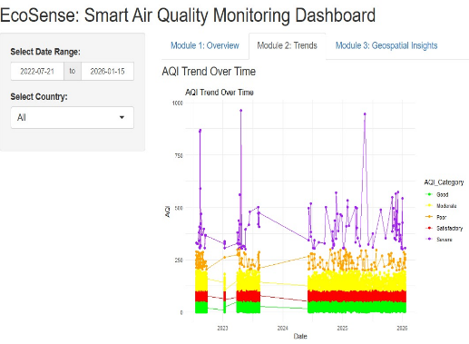
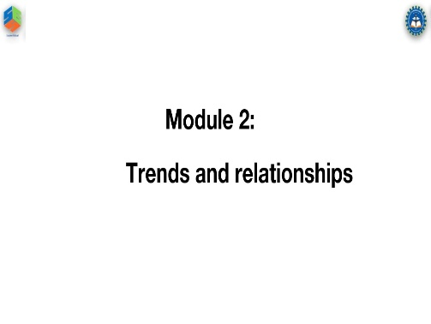
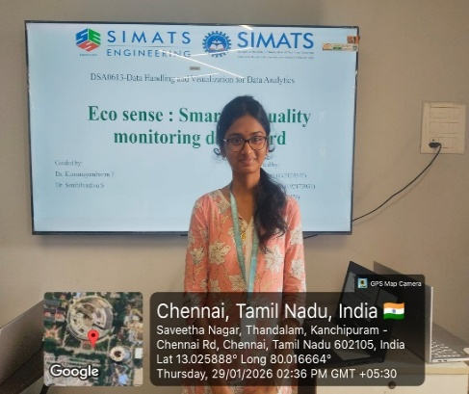

Project Description: (here you write what you did in this project contribution) including Model Description.
Trends and Relationships focuses on analyzing temporal variations in air quality and identifying relationships among key environmental parameters within the Eco Sense dashboard. In this module, i implemented the complete trend and relationship analysis using the R programming language, leveraging its powerful data analysis and visualization capabilities. AQI trends are examined over selected time periods to detect seasonal patterns, pollution peaks, and long-term changes in air quality. Correlation analysis is performed to study the relationships between pollutants (PM2.5, PM10, and gaseous pollutants) and meteorological factors such as temperature and humidity. This R-based implementation enables accurate statistical analysis and clear visual representations, supporting data-driven insights for effective air quality monitoring and management.

Student Signature Guide Signature

